**SSRP project templates**

**Title:** Farmer Organisations and the Sustainability of Small Farms in India

**Theme:** Food security, biodiversity and urban/rural dynamics

**SDG’s:** The project will address the intersecting environmental, social, economic and technological challenges of sustainable development that connect poverty reduction (SDG 1) and food security (SDG 2) in ways that increase gender equality (SDG 5), generate economic growth through decent and inclusive work (SDG 8), promote responsible production of food and other agricultural products (SDG 12), tackle climate change (SDG 13), and protect and conserve biodiversity (SDG 15).

**PI and Co PI details:**

Principal Investigator

Dr Pedram Rowhani

Senior Lecturer in Geography

School of Global Studies

Email: [P.Rowhani@sussex.ac.uk](mailto:P.Rowhani@sussex.ac.uk)

Telephone: 01273 873 141.

Co-Investigators

Dr Dominic Glover

Research Fellow

Rural Futures cluster

Institute of Development Studies.

Email: [D.glover@ids.ac.uk](mailto:D.glover@ids.ac.uk)

Dr Shova Thapa Karki

Lecturer in Entrepreneurship and Sustainability

School of Business, Management and Economics.

Email: [S.Thapa-Karki@sussex.ac.uk](mailto:S.Thapa-Karki@sussex.ac.uk)

Dr Seife Ayele

Research Fellow

Business, Markets and the State cluster

Institute of Development Studies.

Email: [S.Ayele@ids.ac.uk](mailto:S.Ayele@ids.ac.uk)

**Project team**:

Postdoctoral researcher (PDRA)

Dr Steven Orchard

Sussex Sustainability Research Programme

Email: [S.e.orchard@sussex.ac.uk](mailto:S.e.orchard@sussex.ac.uk)

In-country partner

Dr Debashish Sen

Director, Peoples Science Institute

Dehradun, India

[psiddoon@gmail.com](mailto:psiddoon@gmail.com)

**Where are you working:** Uttarakhand and Madhya Pradesh, India

**Project summary in 140 characters:**

Analyse the ways FOs influence cooperation among smallholders and the implications for sustainability and livelihood resilience to shocks and stresses

**Overview of project:**

This project investigates how FOs influence: (i) smallholder utilization of different forms of cooperation to access the resources necessary to support their livelihoods in the face of rapid social and environmental change; (ii) the barriers and opportunities to participate in different forms of cooperation; and (iii) rural social-ecological system dynamics. Providing insights into how FOs influence cooperation among smallholders in the face of rapid global change aligns with SSRP aims to inform sustainable policies and practices, in this case to promote sustainable rural livelihoods, food security and biodiversity conservation. This is crucial for tackling the intractable global challenge of feeding a growing population within the context of climate change and biodiversity loss.

**Project description:**

The project design comprises an interdisciplinary framework and mixed methods approach to integrate the economic (financial and commercial viability of smallholder enterprises), environmental (the agro-ecological performance of smallholder farms) and social (the networks and relations of local communities) dimensions of sustainability and resilience. The project focusses on South Asia as 83% of farms are small and they employ more than 50% of the population, including many groups vulnerable to price spikes and other shocks and stresses. The PDRA will design and conduct the research, employing a mix of participatory methods, household surveys and semi-structured interviews with key informants, with the support of an interdisciplinary team of Sussex researchers combining natural and social science expertise. Fieldwork will be conducted between February and December 2018 in Uttarakhand and Madhya Pradesh, India, in cooperation with the People’s Science Institute (PSI, Dehradun, Uttarakhand, India). PSI is a non-profit research and development organisation that works with rural communities vulnerable to shocks and stresses, supporting them to develop practical solutions. The proposed outcomes of the research include: capacity building of the PDRA and in-country partners, PSI; academic publications; development of funding proposals; conference presentation; and interdisciplinary integration within SSRP. The intended impact of this research is to inform rural policy and practical actions by highlighting the potential of smallholders to build the resilience and sustainability of rural communities, livelihoods, and biodiversity in a context of rapid global change.

**Timeline and funding:** September 2017 – March 2019. £100, 000

**Photos:**

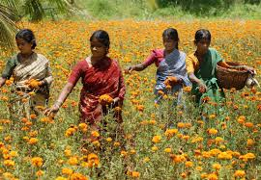

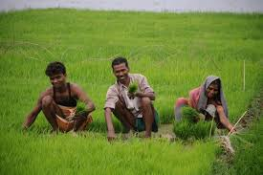

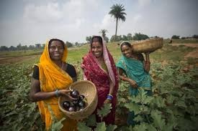

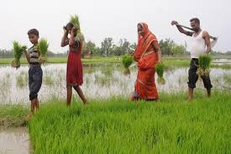

**Any useful websites or links:**

Peoples Science Institute: <http://peoplesscienceinstitute.org/index.html>